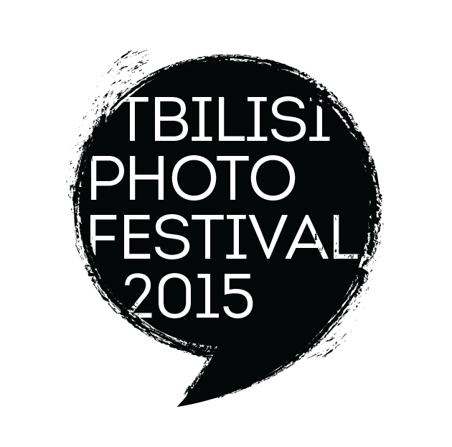
2 ORIGINAL MASTERCLASSES
WITH KLAVDIJ SLUBAN

IN TBILISI, GEORGIA

Photography as a Language

FROM SUNDAY APRIL 24 TO FRIDAY APRIL 28 IN 2016

ORGANIZED BY THE TBILISI PHOTO FESTIVAL

Two creative Masterclasses to discover Tbilisi, famous for the warmth of its inhabitants and its rich cultural heritage, with KLAVDIJ SLUBAN, an internationally renowned photographer, in order to build one's personal photographic writing. These two most original Masterclasses are based on the various layers the Georgian capital can offer to the sensitive viewer. It also bears this capacity to enhance one's own inner perceptions.
For its 6th edition, the TBILISI PHOTO FESTIVAL is launching a series of outstanding Masterclasses, based on the extraordinary points of view Tbilisi and its surroundings offer to create a personal photographic language.
These Masterclasses are lead by world famous photographers, acclaimed both for their personal creation as well as for their capacity to transmit and share their knowledge and experience.

Both Klavdij Sluban's Masterclasses take place at two specific seasons of the year: automn and spring. In each case, these two seasons offer the mild climate of the Caucasus. Wandering in the old town or exploring the near-by countryside gives the opportunity to meet the Georgian people, famous for their warmest welcome.

KLAVDIJ SLUBAN has been traveling in Georgia since 1999 and knows very well the area. One of his photographic essays is entitled Around the Black Sea – winter journeys, for which he was awarded the Villa Médicis Hors-les-Murs. He also worked with teenagers in two different jails, Tbilisi and Khoni. A documentary film with Henri Cartier-Bresson, "Just Plain Love", Arte, was released in 2001.
(link : https://www.youtube.com/watch?v=AJqzpOdZjZQ)
K.Sluban has had numerous exhibitions in Georgia. Most recently, in 2015, during the Tbilisi Photo festival, at the Museum of the Writers' House, "Inhabiting Exile".

THE TBILISI PHOTO FESTIVAL
link : http://www.tbilisiphotofestival.com/en/ )
facebook : https://www.facebook.com/tbilisiphotofestival
The Tbilisi Photo Festival is a major event in the Caucasus area. Its collaboration with international festivals such as the Rencontres d'Arles makes it particularly specific. The professional aspect acquired with time and experience is combined with he human warmth and efficiency of the charming team, speaking many a language. NESTAN NIJARADZE who founded the festival in 2009 and has been its Director since then, makes it unique by inviting internationally famous photographers but also photographers from he Caucasus, less known in the western world but as convincing in terms of personal commitment and quality of work. Trained in Paris, Nestan has curated many major exhibitions around the world and does portfolio reviewing in the most important festivals.

THE MASTERCLASS FROM SUNDAY SEPTEMBER 27 TO FRIDAY OCTOBER 2nd, 2015 takes place during the Tbilisi Photo Festival. Participants can attend the various openings, conferences, projections, for free.
THE MASTERCLASS FROM SUNDAY APRIL 24 TO FRIDAY APRIL 29, 2016 takes place at a specific moment of the year. During this week, various celebrations, ceremonies and feasts occur. This will also be the week before Orthodox Easter. Many encounters to be expected.

The SPECIFICITY of the TBILISI PHOTO FESTIVAL Masterclasses is that the participants are totally taken care of during the whole Masterclass. This starts at their arrival in Tbilisi, generally at the airport, till the departure time.
The philosophy of these Masterclasses is to combine a friendly atmosphere in a country where people are famous for their hospitality with hard-working sessions to give shape to one's inner feelings. Photography language requires to be available while on the ground and then, in a second phase, to realize how much EDITING is crucial to create a coherent series.

THE PROGRAM will consist of exploring the old town, with its wooden houses and balconies, the numerous inner courtyards with a whole life inside, but also factory-towns from the Soviet Union times in the outskirts of Tbilisi to monasteries from the 15th century, hosted by the monks.

Each participant's accommodation is in the centre of the old town. All of the main spots can be visited on foot. All meals are taken together, in gastronomic restaurants, mixing various kinds of food, for all tastes. A day by day program is proposed in order to have a view of the week we are going to spend together.

MAIN GOALS

• Each participant comes with one or several series of images (between 20 and 40), printed on PAPER, small size. « SHOW ME YOUR PHOTOS AND I WILL TELL YOU WHO YOU ARE ». A constructive criticism will give each participant the way to channel one's personal point of according to the various situations.
• Klavdij Sluban's experience in sharing generously his knowledge gives each participant the possibility to find one's personal writing (or style)
•There will be every day photo sessions. Editing by the end of the day.

WHO CAN JOIN THIS WORKSHOP?

Anyone who has a passion for the still image: professional photographers, artists, students of photography and art, amateurs of photography and art, etc...
Klavdij Sluban believes that every individual has the capacity to build one's own visual language when PASSION for the image and the right GUIDANCE co-exist..

FINAL PRESENTATION AS SLIDESHOWS

•A slideshow will be the achievement of the final selection, done in total agreement between the participant and K.Sluban. The slideshows of all participants will be publicly projected the last evening of the Masterclass on a wide screen. Georgian public is eager for photography, therefore expect a crowd.
The slideshows will be prepared and mounted by the professional, efficient and experienced team of the Tbilisi Photo Festival.

WHAT TO BRING
•all material – photos, portfolios, etc – relevant to your work, images in PRINT FORM, SMALL SIZE.
•your digital camera, one lens only & its accessories (extra batteries, memory cards, cable for image transfer to a computer, USB key, external hard disk, etc)
•a notebook or recording device to facilitate note-taking during the Masterclass since many references on photographers, books, main exhibitions places...will be given any time.
•very much appreciated: your personal computer

SPOKEN LANGUAGES
English, French, Russian...Georgian

IF YOU NEED ANY EXTRA INFORMATION

TAMTA CHELIDZE, coordinator of the festival and in charge of the Masterclass, speaks English, Russian and...Georgian.

Phone: + 995 593 56 03 04
email: masterclass@tbilisiphotofestival.com
answers will be given in the same language as the one used for the questions.

ACCOMMODATION
All accommodation places are located in the old town, at a 10 mn walk from one another.
All group sessions also take place in the old town in a special space appropriate to receive such kind of Masterclasses, with specific equipment.
This place is secured. All belongings we do not need when going out after an editing session can be left there in total confidence.

PRICE

The cost of a one week Masterclass is 950,00€.

The formula which includes all transportation (from and to airport, also visits out of town, etc), 3 meals a day and a SHARED ROOM with two beds costs: 450,00€

The formula including all transportation (airport but, visits out of town, etc), 3 meals a day and a SINGLE ROOM costs: 650,00€

The principle is based on first come first served.
The number of participants is limited to 10.
A first payment, half of the total amount, will secure your inscription. The second half is expected at the latest one week before the Masterclass starts.

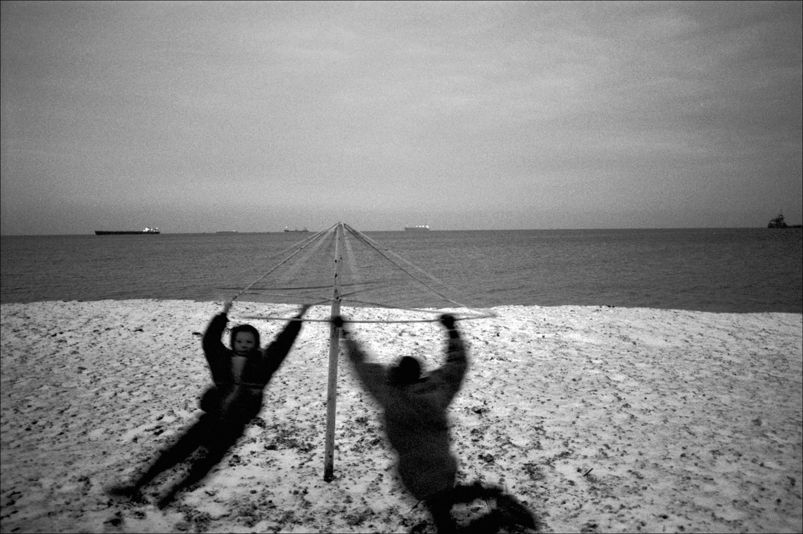

© Klavdij Sluban. Ukraine 1999

PROGRAM OF THE MASTERCLASS FROM SUNDAY APRIL 24 TO FRIDAY APRIL 29, 2016

Each participant is being awaited at their arrival point, generally the airport, and driven to their staying place.

This spring Masterclass will keep the highlights of the automn Masterclass: sharing a common passion in Tbilisi, an extraordinary place offering various human encounters, visiting of the old town and historical places, including former Soviet Union remains...

Yet, this Masterclass will particularly enhance certain aspects of Georgian culture. Such as the Marionette / Puppet Theatre, the Folkloric and Traditional dance School, the Traditional Music Group as well as this specific period of Georgian religious culture: the whole week will be a week of preparation for Orthodox Easter, celebrated on May the 1st.

Each participant will be offered the opportunity to join one of these communities and share their every day life. Thanks to the network the Tbilisi Photo Festival has established throughout the years, such approaches are possible.

A slideshow of all participants will be projected in public the last evening of the Masterclass on a wide screen. Georgian public is eager for photography, therefore expect a crowd.
The slideshows will be prepared and mounted by the professional, efficient and experienced team of the Tbilisi Photo Festival.
The public projection of the slideshows will take place in FRONT LINE CLUB, an avant-garde cultural space dedicated to multimedia arts and modern technology, among others.

As for the automn Masterclass the application is based on first come first served.

•SATURDAY APRIL 23, 2016. AT 7.30 PM, welcoming dinner with all the participants.A way of starting in a relaxed atmosphere...

•SUNDAY APRIL 24: 9AM to 5.30 PM
Morning: reading of the portfolios. Constructive criticism and advices about the way to channel photographically one's perception of the various events experienced during the week to come.
1PM to 2.30 PM: lunch in the old town.
Afternoon: discovery of the old town on Robert Capa's footsteps who visited Tbilisi in 1947 with John Steinbeck.
Editing
7.30PM: dinner in a restaurant which main specialty is traditional khachapuri.
•MONDAY APRIL 25: 9AM-5.30PM
Morning: wandering throughout the old town. Some main spots not to be missed will be our red thread: Kote Abkhazi and its staircase giving onto inner courtyards, the many churches, synagogues and the mosque...getting lost in the small streets full life.
1PM to 2.30PM: lunch in the old town
Afternoon: visit to the Folkloric Dance Group of the Georgian National Ballet of Soukhicvili, having toured all over the world. Visit during a rehearsing of the Group. Possibility to meet afterwards the dancers and establish a contact.
Editing
7.30PM: dinner in a wine cellar, run by a young couple specialized in bio products.

•TUESDAY APRIL 26: 8AM TO 5PM
Morning: departure at 8AM out of town for a half an hour drive.
3 highlights: on the so-called 'military highway', leading up to the Russian border, where the road clings to the side of the turquoise Zhinvali Reservoir. Extraordinary landscape.
Stop at Ananuri fortress, with its sublime architecture, panoramic view and little typical village.
Lunch in a village restaurant with traditional cooking and embroidered napkins.
On the way back, stop at Mitskheta, Georgian spiritual heart and ancient capital. Overwhelming view. Possibility to visit the monks leaving inside the monastery.
Back at 5PM and rest.
7.30: dinner in the restaurant of the Ethnographic Museum on the panoramic terrace.

•WEDNESDAY APRIL 27:
Morning: Departure towards Rustavi, at a half an hour drive which is an industrial city built during the former Soviet Union regime, dominated by a huge factory (photographed by Henri CARTIER-BRESSON). Lunch on the way back. Back at 3PM.Editing.
Break
6PM: Anchiskhati basilica, oldest church in Tbilisi, in the heart of the old town. Visit during the liturgy, traditional male choir singing, polyphony. Possibility to meet the monks afterwards.
8PM: dinner

•THURSDAY APRIL 28 : 10AM to 5.30PM
10AM: Tbilisi Flea Market. Incredibly huge, running all over the bank of the Kura river. Visit of old parts of Tbilisi where craftsmen still work in the ancient way (iron, wood...)
Lunch: 1PM to 2.30PM.
Afternoon: visit of the thermal baths where Alexandre Dumas and Pushkin had also been. The great Russian poet wrote these were the most relaxing baths he had ever had...
4PM: editing
7.30PM: dinner with musicians performing traditional music.

•FRIDAY APRIL 29
The morning is dedicated to the final editing for the slideshow. The technical team of the Tbilissi Photo Festival, specialized in this kind of events, will be in charge of preparing the slideshows with the photos selected in common agreement between each participant and Klavdij Sluban.
1.30PM to 2.30PM: lunch
Afternoon dedicated to the visit of the Museum of the Writers' House, beautiful atmosphere with a nice inner garden, where Robert Capa and John Steinbeck gave a conference in 1947. Guided visit of the National Museum (if interested).
8PM: public projection of the slideshows in FRONT LINE CLUB, an avant-garde cultural space dedicated to multimedia arts and modern technology, among others.
9PM : SURPRISE DINNER

Each participant will be driven to their departure point, on whichever day they leave.

Slideshows will be sent soon after to all participants who agree to share their slideshow with the other participants.

Klavdij SLUBAN

Winner of the European Publishers Award for Photography 2009, of the Leica Prize (2004) and of the Niépce Prize (2000), main French prize in photography, Klavdij Sluban is a French photographer of Slovenian origin born in Paris in 1963.
He develops a rigorous and coherent body of work, nourished by literature, never inspired by immediate and sensational current affairs, making him one of the most interesting photographers of his generation. The Balkans, the Black Sea, the Baltic Sea, the Caribbean, Central America, Russia, China and the Antarctic (first artistic mission in the Kerguelen islands) can be read as many successive steps of an in-depth study of a patient proximity to the encountered real. His images have been shown in such leading institutions as the Metropolitan Museum of Photography of Tokyo, the Maison Européenne de la Photographie in Paris, the Rencontres d'Arles, the Museum of Photography in Helsinki, the Fine Arts Museum in Canton, the Musée Beaubourg, the Museum of Texas Tech University…
His many books include East to East (published simultaneously by Actes Sud, Dewi Lewis, Petliti, Braus, Apeiron & Lunwerg with a text by Erri de Luca), Entre Parenthèses, (Photo Poche, Actes Sud), Transverses, (Maison Européenne de la Photographie) and Balkans -Transit, with a text by François Maspero (Seuil).
Since 1995, Sluban has been photographing teenagers in jails. In each prison he organizes workshops with the young offenders to share his passion. First originated in France, in the prison of Fleury-Mérogis with support from Henri Cartier-Bresson during 7 years, as well as Marc Riboud and William Klein punctually. This commitment was pursued in the disciplinary camps of Eastern Europe –Serbia, Slovenia, Ukraine, Georgia, Moldavia, Latvia – and in the disciplinary centres of Moscow and St Petersburg as well as in Ireland. From 2007 to 2012, Sluban has been working in Central America with imprisoned youngsters belonging to maras (gangs) in Guatemala and Salvador. In 2015, he started photographing imprisoned teenagers in Brazil.
In 2013, the musée Niépce showed a retrospective of K.Sluban's work, After Darkness, 1995-2012.
In 2015/16, he was awarded the Villa Kujoyama Residence in Kyoto, Japan.
www.sluban.com
www.facebook.com/klavdij.sluban

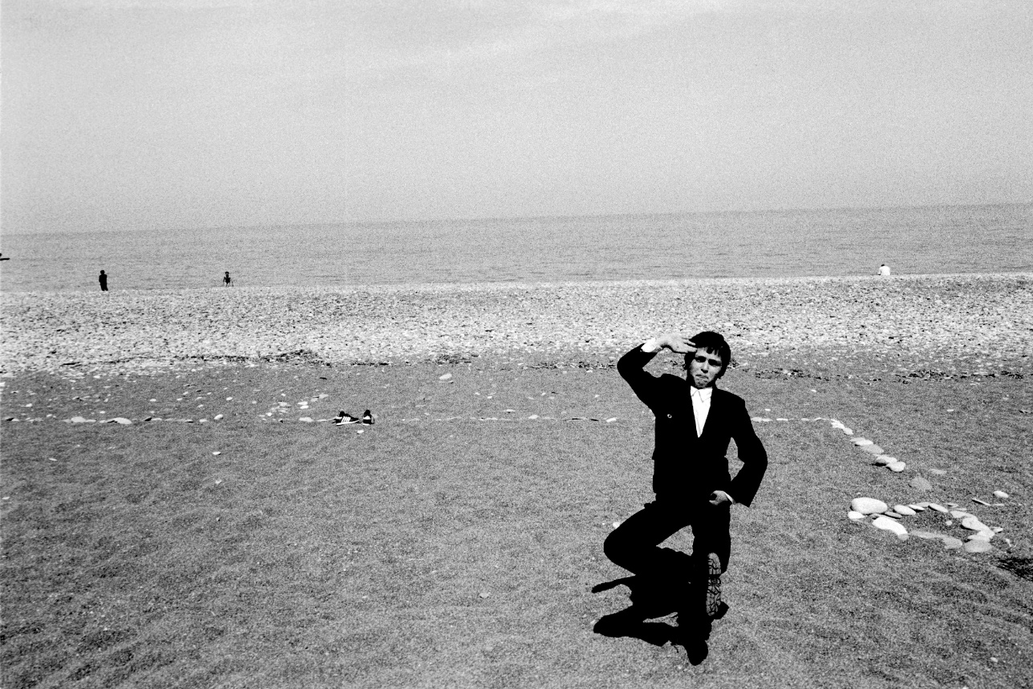
© Klavdij Sluban. Georgia 1999

