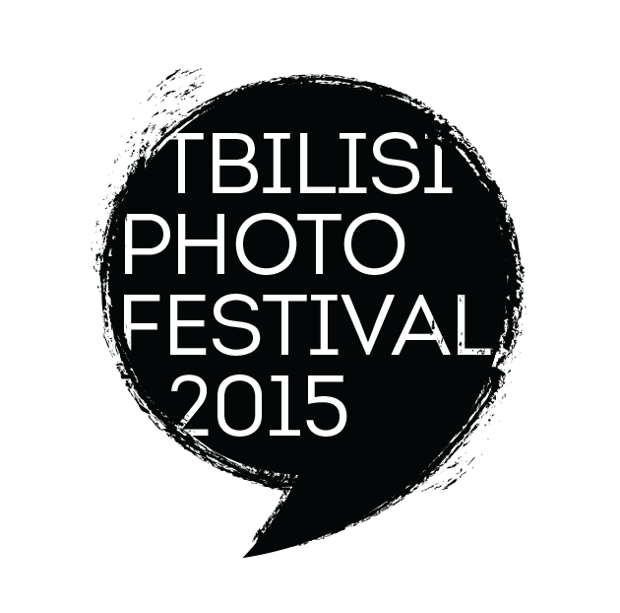

ORIGINAL MASTERCLASS
WITH ANTOINE D’AGATA

Personal Odyssey : Road Trip Diary

IN TBILISI, GEORGIA

• FROM SUNDAY APRIL 24 TO FRIDAY APRIL 28 IN 2016

ORGANIZED BY TBILISI PHOTO FESTIVAL

This masterclass revolves around photography as a means for asserting a personal perception of the world. Looking beyond the purely documentary, images making up a diary or inventory allow their inventor to cut free from the constraints underlying the transcription of objective reality.
Antoine d’Agata's concern is to pare down the photographic act to the need to recount ordinary or extreme experiences. Each participant will be asked to examine the ultimate goal of his approach, to play an active part in his own images, and to work on the texture of reality.
Since images, like words, only take on meaning when brought together, the workshop will focus on finding the most relevant form for each individual stance.
Working with Antoine d’Agata, participants must be ready to photograph intensively throughout the workshop and to extend the limits of their approach. They will have to confront their obsessions and contradictions as they shape a series of images conveying in real or fictional terms their private relationship with the world.

Antoine D'Agata
A Magnum member since 2004, won the Nièpce Prize in 2001. Images that push back the boundaries of reportages make Antoine D’Agata one of the most fascinating photographers on the scene of contemporary photography.
www.magnumphotos.com

Antoine D’Agata has been travelling to Georgia since 2009. He was one of those 10 Magnum photographers that worked on the project Georgian Spring by Magnum. His first exhibition in Georgia – Vortex - was shown in the frame of Tbilisi Photo Festival 2013. The second one - Eclipse – the series of the photos taken in Georgian in 2009 and 2013 was part pf the program of Tbilisi Photo Festival 2015.

TBILISI PHOTO FESTIVAL

The Tbilisi Photo Festival was first launched in 2010, in partnership with Les Rencontres d’Arles. Six editions later it has become not only the most important photo festival in the region but one of the major annual cultural events in the Caucasus.
The Festival aims:
- to be a central meeting point for photography from different regions – Asia, Iran, Turkey, Europe, Russia and the Arab world;
- to showcase the best of world photography and to promote emerging regional photography.
Each year, the festival attracts internationally renowned photographers, curators, photo editors and leaders of other major photo festivals to the Georgian capital, along with thousands of photography fans. It is a crossroads for new ideas in photography.

For its 6th edition, the Tbilisi Photo Festival is launching a series of Masterclasses, capitalising on the city’s place as a crossroads of cultures and the scope it offers for photographic interpretation.
These Masterclasses are led by world famous photographers, acclaimed both for their work and their ability to communicate and share their ways of seeing.

www.tbilisiphotofestival.com
facebook : https://www.facebook.com/tbilisiphotofestival

TBILISI PHOTO FESTIVAL Masterclasses

The SPECIFICITY of the TBILISI PHOTO FESTIVAL Masterclasses is that the participants are totally taken care of during the whole Masterclass. This starts at their arrival in Tbilisi, generally at the airport, till the departure time.

THE PROGRAM of the masterclass will consist in intensive shooting in Tbilisi and editing sessions, as well as the trips outside of Tbilisi as part of the shooting sessions.

Each participant's accommodation is in the centre of the old town. All of the main spots can be visited on foot. All meals are taken together, in gastronomic restaurants, mixing various kinds of food, for all tastes.

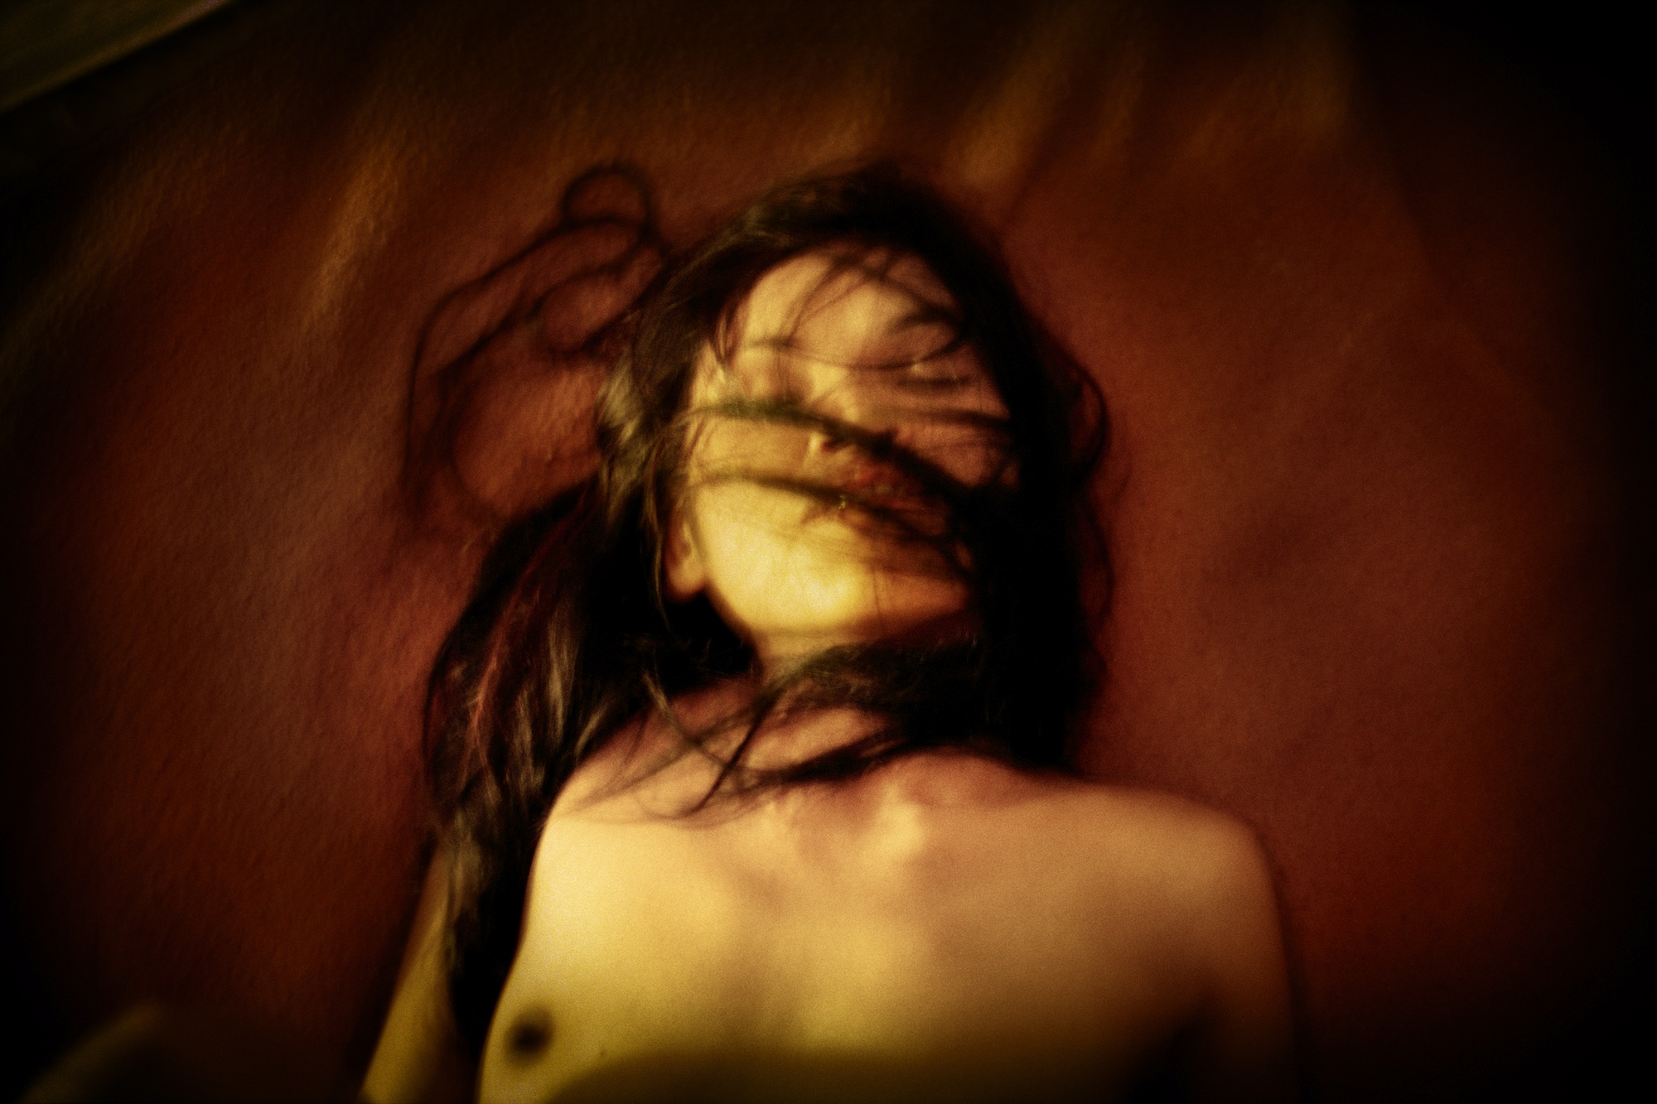

©Antoine D’Agata

MAIN GOALS
Working with Antoine d’Agata, participants must be ready to photograph intensively throughout the workshop and to extend the limits of their approach. They will have to confront their obsessions and contradictions as they shape a series of images conveying in real or fictional terms their private relationship with the world.

WHO CAN JOIN THIS WORKSHOP?

- Anyone who has a passion for the still image: professional photographers, artists, students of photography and art, amateurs of photography and art, etc...

WHAT TO BRING

- Each participant should have one or several series of images (between 20 and 40), printed on PAPER, small size. A constructive criticism will give each participant the way to channel one's personal point of according to the various situations.
- all material – photos, portfolios, etc – relevant to your work, images in PRINT FORM, SMALL SIZE.
- digital camera, one lens only & its accessories (extra batteries, memory cards, cable for image transfer to a computer, USB key, external hard disk, etc)
- a notebook or recording device to facilitate note-taking during the Masterclass since many references on photographers, books, main exhibitions places...will be given any time.
- very much appreciated: your personal computer

FINAL PRESENTATION AS SLIDESHOW

- A slideshow will be the achievement of the final selection, done in total agreement between the participant and Antoine D‘Agata. The slideshows of all participants will be publicly projected the last evening of the Masterclass. Georgian public is eager for photography, therefore the crow dis expacted. A slideshow of all participants will be projected in public the last evening of the Masterclass on a wide screen. Georgian public is eager for photography, therefore expect a crowd.
- The public projection of the slideshows will take place in FRONT LINE CLUB, an avant-garde cultural space dedicated to multimedia art
- The slideshows will be prepared and edited by the professional, efficient and experienced team of the Tbilisi Photo Festival.

SPOKEN LANGUAGES
English, French, Russian...Georgian

IF YOU NEED ANY EXTRA INFORMATION

You can get in touch with the team of masterclasses :

mail: masterclass@tbilisiphotofestival.com

answers will be given in the same language as the one used for the questions.

ACCOMMODATION

All accommodation places are located in the old town, at a 10 mn walk from one another.
All group sessions also take place in the old town in a special space appropriate to receive such kind of Masterclasses, with specific equipment.
This place is secured. All belongings we do not need when going out after an editing session can be left there in total confidence.

PRICE

The cost of a one week Masterclass is 950,00€.

The formula which includes all transportation (from and to airport, also visits out of town, etc), 3 meals a day and a SHARED ROOM with two beds costs: 450,00€

The formula including all transportation (from and to airport, also visits out of town, etc), 3 meals a day and a SINGLE ROOM costs: 650,00€

The principle is based on first come first served.
The number of participants is limited to 10.

A first payment, half of the total amount, will secure your inscription. The second half is expected at the latest one week before the Masterclass starts.

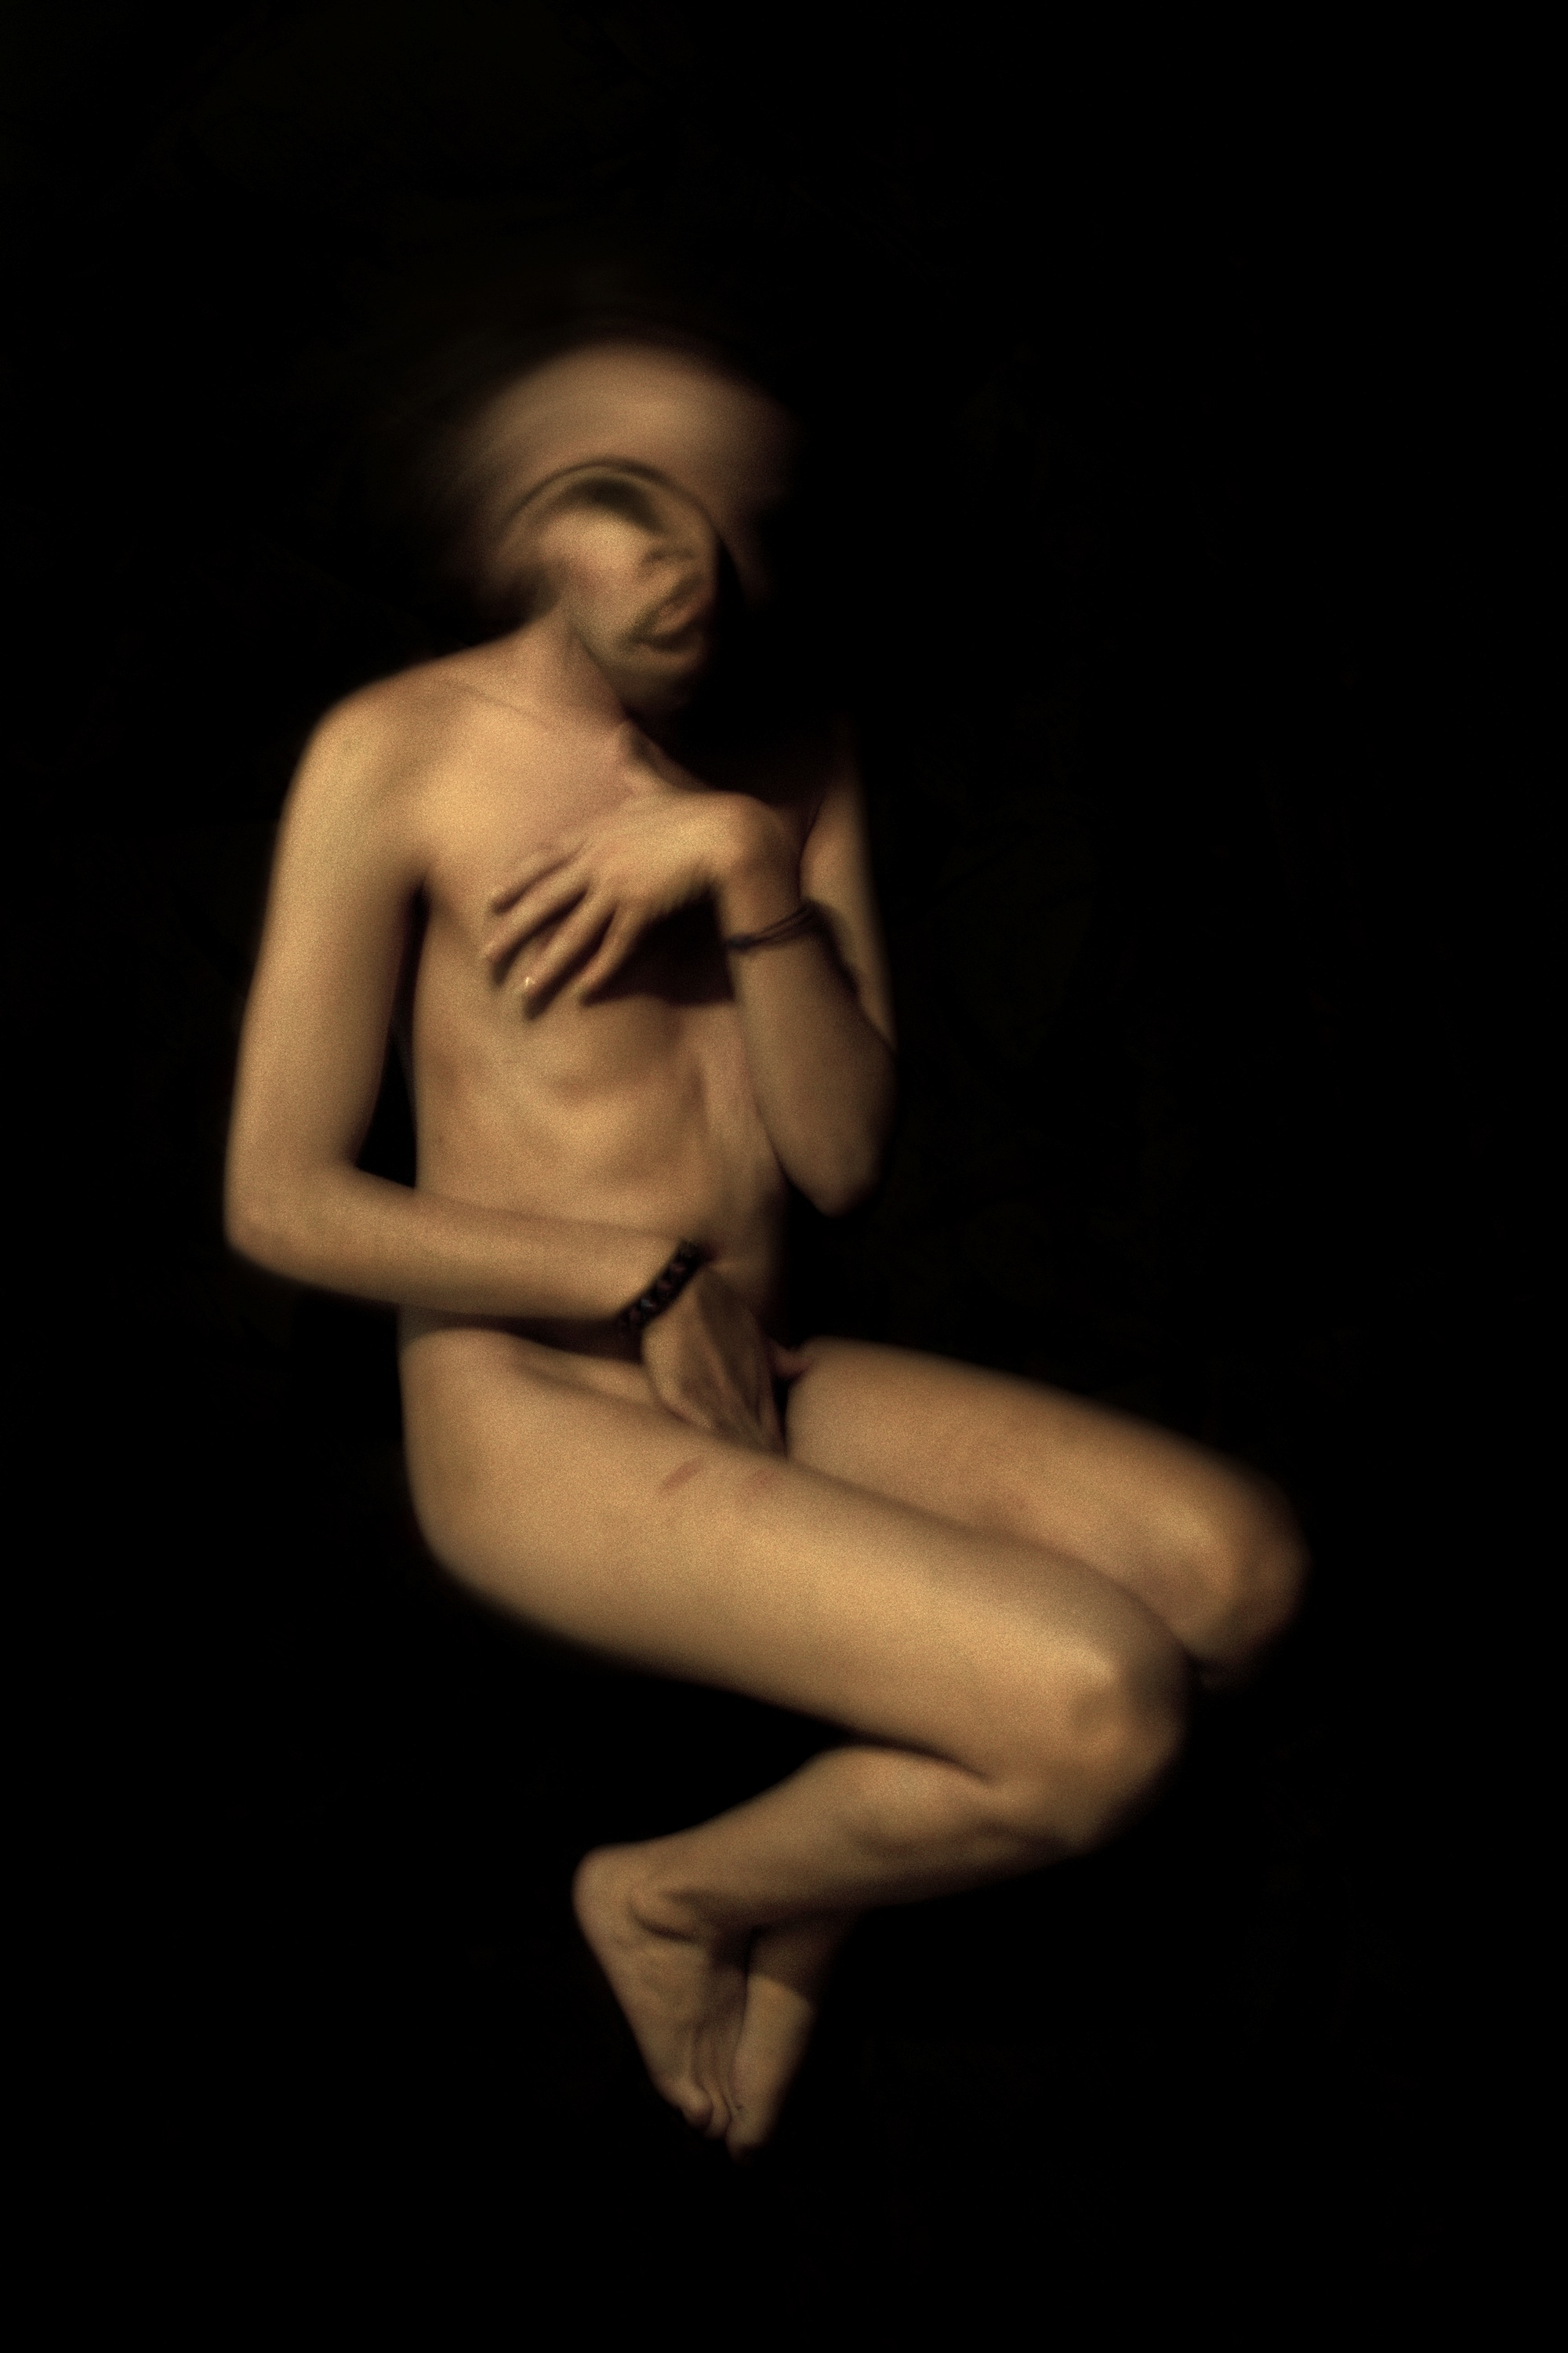

© Antoine D’Agata

